Controlling Molecular Orbital Gating in Molecular Junctions by One CH2 Group

*Ziyu Zhang1, Senthil Kumar Karuppannan1, Christian A. Nijhuis1,2\**

1 Department of Chemistry, National University of Singapore, 3 Science Drive 3, Singapore 117543, Singapore

2 Centre for Advanced 2D Materials and Graphene Research Centre, National University of Singapore, 2 Science Drive 3, Singapore 117542, Singapore

*Author to whom correspondence should be addressed: chmnca@nus.edu.sg

*Target journal:*

TOC: design with the scientific insights and appealing

Abstract:

**Introduction**

Molecular junctions, where an individual molecule or molecular array sandwiched between two electrodes, have shown interesting functions such as diodes, light-emission and memory. To guide the design of future generation device, it is now more important than ever to understand the mechanism of electron tunnelling through molecules. With the recent advances in theory as well as experimental studies, we are breaching Landauer tunnelling and the Marcus electron transfer in the context of a molecular junction. Here we take one step further to investigate the coupling between the molecules and the electrodes and its impact on the mechanism of electron transport. We have demonstrated that by adding one CH2 unit to reduce this coupling strength, we can turn on the intramolecular gating effect and push the electron transfer to the inverted Marcus regime.

Two models are most used to describe charge transport mechanisms through molecular junctions: coherent tunnelling and incoherent hopping. The former treats molecule as a ballistic conductor with only elastic scattering while the latter assumes strong electron-nuclear coupling and complete localization of electrons. Landauer formula and Marcus theory are the theories frequently used to describe these mechanisms respectively. Incoherent tunnelling was known to be temperature-independent and hopping should be thermally assisted and strongly dependent on the temperature. Lately intermediate mechanisms and more complex patterns of activation energies were found in molecular junctions, crossing the boundary between Landauer and Marcus theories. One of our previous study showed that the when a ferrocene unit (Fc-) is connected to a conjugated backbone, they form a donor-acceptor pair. In a tunnelling junction of Fc-(CH2)n-DPA-CH2-SH (n = 1-3, DPA = diphenylacetylene), The HOMO on Fc and the LUMO on DPA can affect the energies of each other when one of them is charged. This effect works as if there is a gate electrode shifting the molecular orbitals with respect to the Fermi level and is referred to intramolecular orbital gating.

To further explore when and why this intramolecular orbital gating effect can occur, we incorporated a conjugated oligophenylene ethynylene (OPE) chain as the acceptor and made self-assembled monolayers (SAMs) with the structure AuTS-S-(Ph-C≡C)n-Fc (n = 1-3) and AuTS-S-CH2-(Ph-C≡C)n-Fc (n = 1-3), abbreviated as OPEn and OPEnC respectively. We fabricated the SAM-based junctions using a eutectic gallium-indium alloy (EGaIn) as the top electrode (Figure 1) and measured their *J-V* response at -1 V to +1 V bias and then systematically studied the temperature dependency of the charge transport in these junctions and obtain the activation energies across this bias window.

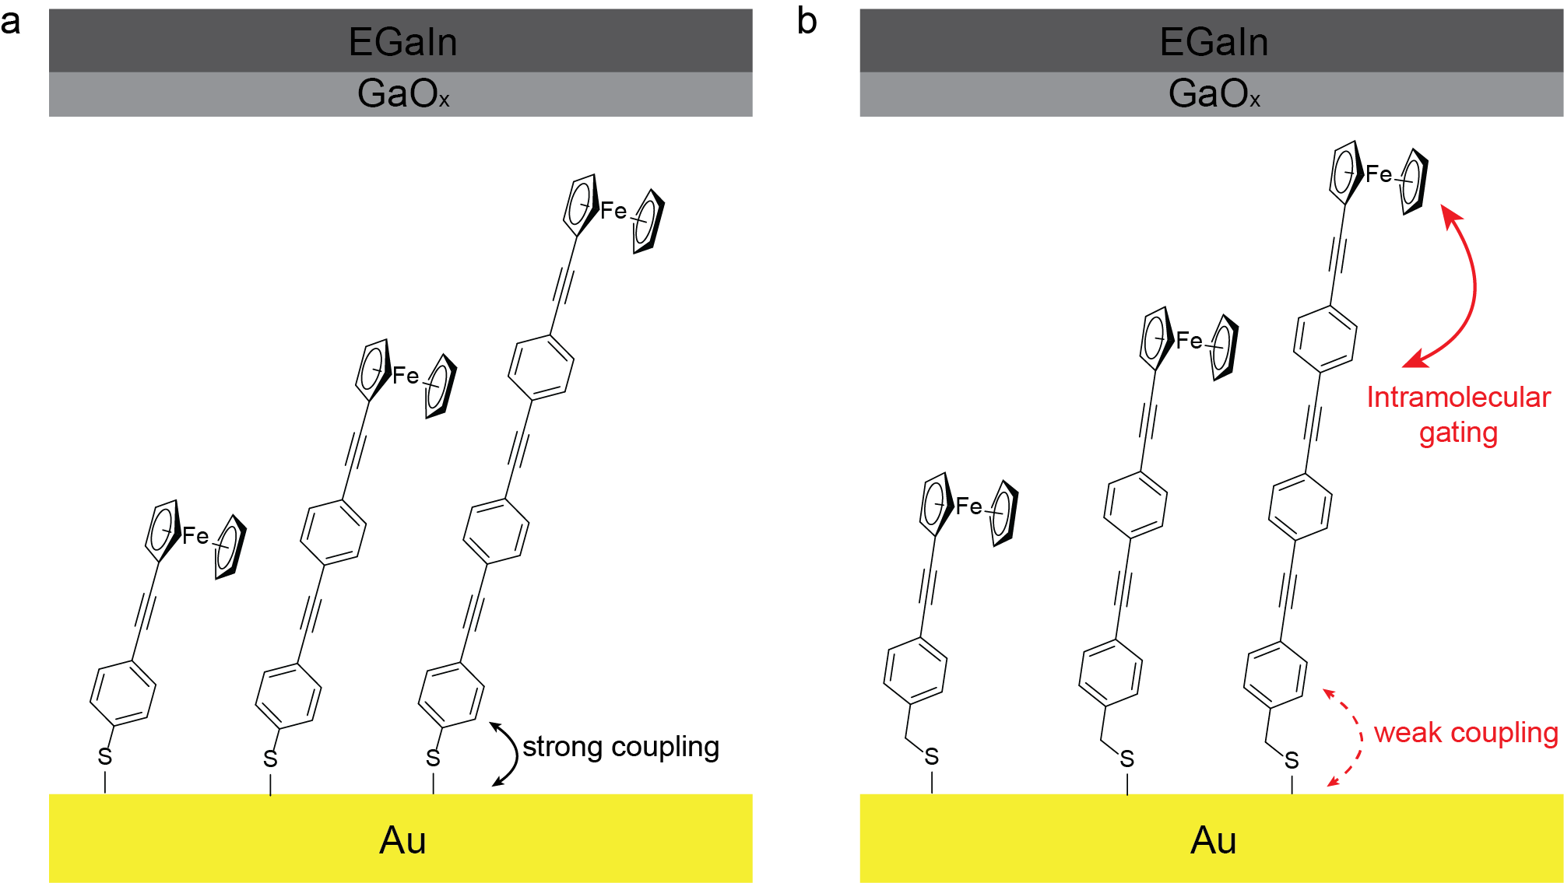

Figure 1. The schematic illustration of the junctions (a) AuTS-S-(Ph-C≡C)n-Fc//GaOx/EGaIn (n = 1-3) and (b) AuTS-S-CH2-(Ph-C≡C)n-Fc//GaOx/EGaIn (n = 1-3).

The bias dependence of the activation energy *Ea* shows a bell-shaped relationship for OPE2C and OPE3C at negative bias. We believe when the Fc group is charged in the negative bias, the LUMO can be gated into the conduction window and give rise to the inverted Marcus regime charge transfer. This phenomenon does not appear for OPE2 and OPE3. We can conclude that the weak coupling between OPE and the Au bottom electrode is essential for the intramolecular gating to take place.

We have demonstrated that by adding one CH2 unit we can significantly change the coupling strength between the OPE and the Au electrode, and thus change the charge transfer mechanism from normal Marcus regime to the inverted Marcus regime.

**Results and Discussion**

*SAM Structure Characterisation*

* We synthesized thiols Fc-(Ph-C≡C)n-SH (n = 1-3) and Fc-(Ph-C≡C)n-CH2-SH (n = 1-3) based on published procedure. The molecules were characterized by 1H NMR, 13C NMR and high-resolution Mass Spectroscopy. SAMs of these molecules on template-stripped Au surface were made according to established protocol. To characterize the structure of the SAMs, we performed cyclic voltammetry and recorded their X-ray photoemission spectra. Figure 2 shows the voltammograms and the analysis of the anodic peaks corresponding to the oxidation of the ferrocene groups.

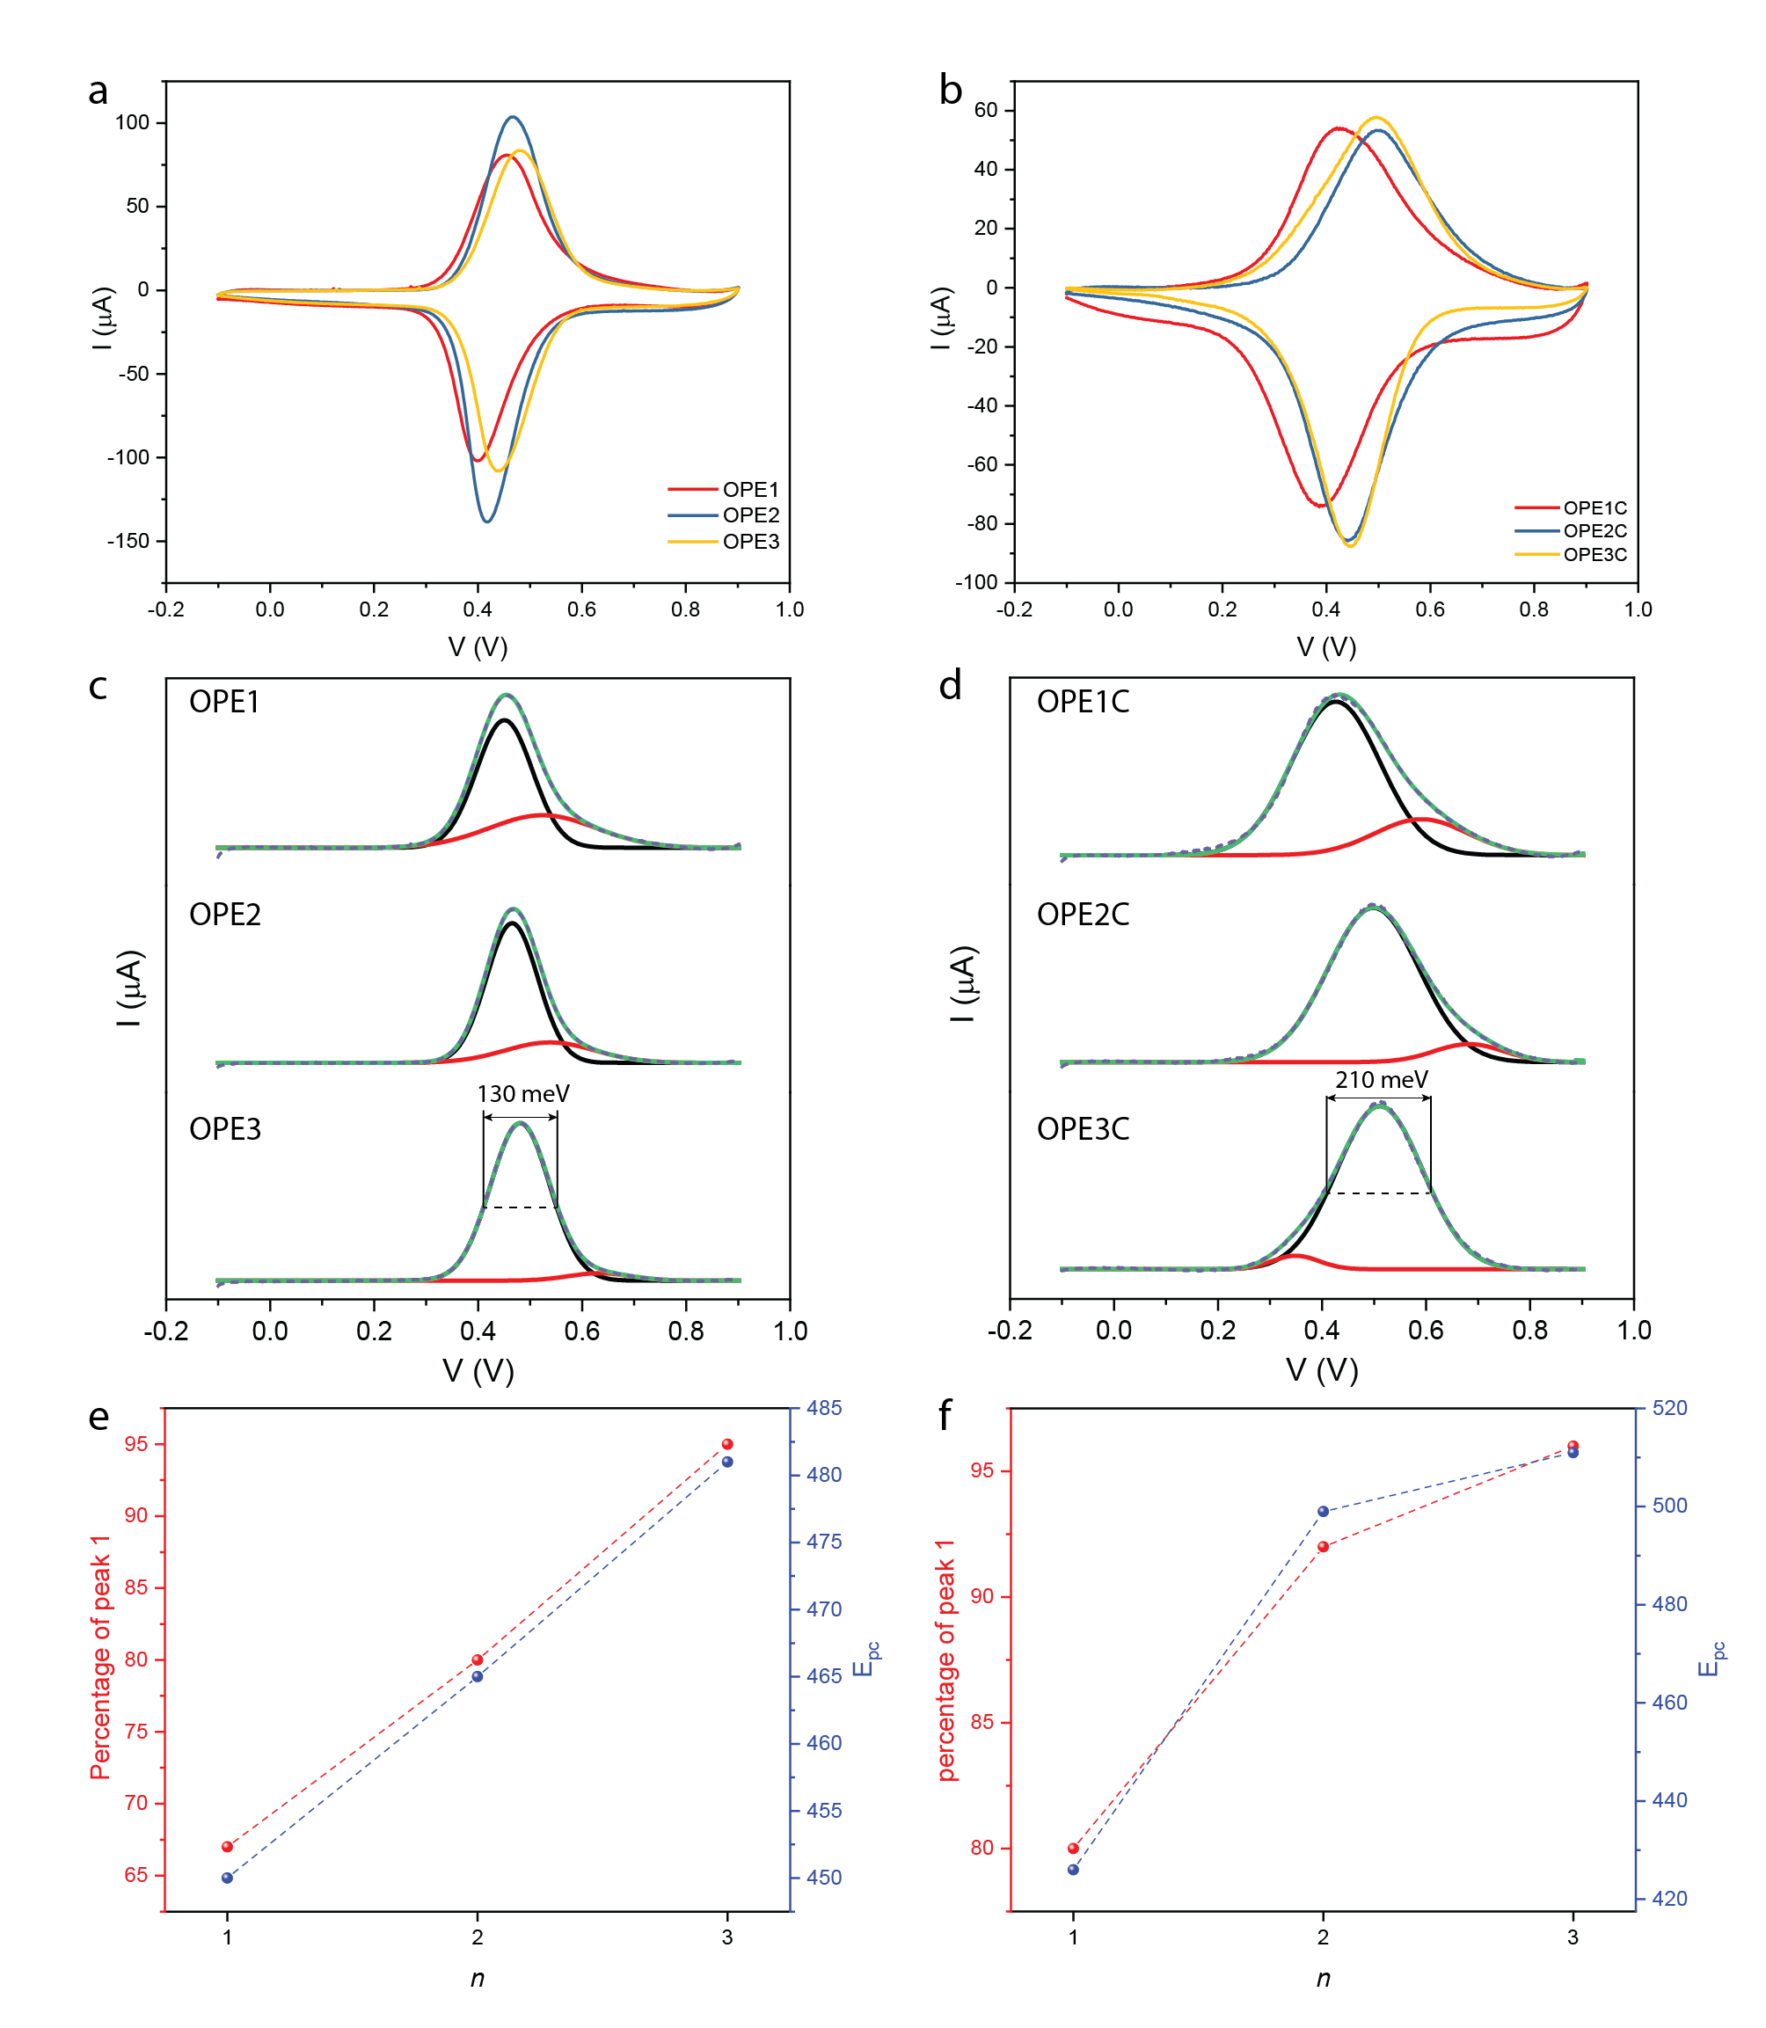

Figure 2. Surface characterisation of studied SAM: Cyclic voltammograms of (a) OPEn and (b) OPEnC measured at a scan rate of 1 V/s. Deconvolution of the anodic peak of (c) OPEn and (d) OPEnC, all peaks were fitted with Gaussian function. The percentage of the main peak and the anodic potential Epc of (e) OPEn and (f) OPEnC as a function of the n.

* Figure 2(a) and (b) shows that for all the SAMs in this study, a characteristic ferrocene redox wave is present at 0.4-0.5 V. The peak deconvolution in Figure 2(c) and (d) shows that for all SAMs, there is a main peak representing the Fc groups in a well-packed SAM, and a small peak likely comes from the physisorbed molecules. In Figure 2(e) and (f), we can observe higher percentage of the main peak up to more than 95% with the increasing number of OPE units, indicating the longer molecules pack in a more uniform manner. We attribute this phenomenon to the stronger π-π intermolecular interaction between the OPE units.
* In addition, the full width at half maximum (FWHM) values for the main anodic peak are ~130 meV for OPEn and ~210 meV for OPEnC. The FWHM for SAMs are determined by the electrostatic interaction between each molecule in the redox process. The larger FWHM values in SAMs of OPEnC also suggest that the molecules are closer to each other and have stronger repulsion when the ferrocene group are charged in the cyclic voltammetry process. We believe the CH2 units weaken the Van Der Waals interaction between OPE and metals and give more freedom for the molecules to pack into monolayers.

*Electrical Characterisation*

* Cone-shaped tips of GaOx/EGaIn were fabricated following previously reported method and used as the top electrode to make the SAM-based junctions. These junctions are stable in the bias window of -1 V to +1 V and give more than 90% yield of non-shorting junctions. We fitted the histogram of current densities in log scale with a Gaussian function and determined the log mean values <log10|*J*|>G. The 95% confidence interval was determined using the Z-test. The results are shown in Figure 3.

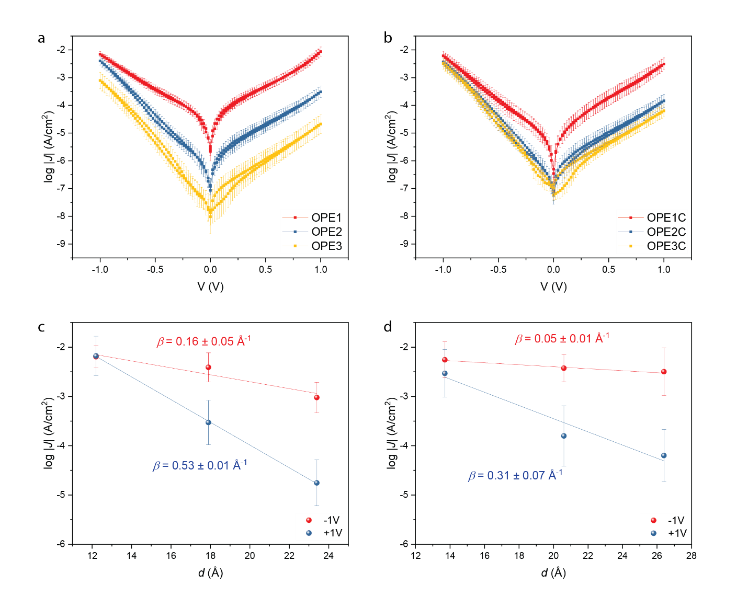

Figure 3. The values of <log10|*J*|>G as a function of voltage V for (a) OPEn and (b) OPEnC. The error bar represents the 95% confidence interval from more than 400 data points. The current density at – 1V and + 1V bias as a function of the molecular length for (c) OPEn and (d) OPEnC. The molecular length was determined by CPK model.

* It is well known that tunnelling current density in molecular junctions decays with the distance by the relation, where is the pre-exponential factor and is the tunnelling decay coefficient. Here it is worth noting that the above general tunnelling equation assumes a constant tunnelling barrier for molecules with similar structure and different length. But in a conjugated system, the tunnelling barrier is affected by the molecular length because of the change in molecular orbital energy.
* At +1 V bias, the *β* values agree well with the other published values in several similar conjugated systems (0.3-0.5 Å-1). The charge transport mechanism is believed to be off-resonant coherent tunnelling. At -1 V bias, *β* becomes smaller and similar to what have been observed for long conjugated chains, indicating the mechanism has switched to hopping.
* When n = 1, the ferrocene group strongly couples with the bottom electrode. When n = 3 this coupling *Γ*bottom is much weaker. On the other hand, *Γ*top is determined by the Van Der Waals interactions between ferrocene and the EGaIn and do not change significantly with n. When a -1 V bias is applied to the junction, the HOMO movement is more prominent for OPE3 and OPE3C. As a result, the HOMO of the longest molecules enters the conduction window at the lowest bias despite that they are further away from the Fermi level at zero bias. Another possible reason for the lack of rectification when n =1 is this SAM is more prone to defect and the leakage current dominates in the positive bias.
* Figure 3(c) and (d) shows *β* values for OPEnC SAMs are smaller than those for OPE SAMs at both biases. One possible explanation is that for OPEnC, the *Γ*bottom is smaller due to the conjugation breaker unit -CH2-. So, at -1 V bias the HOMO level are closer to the top electrode, further reducing the tunnelling barrier.

*Temperature-dependent J-V Measurement*

* To investigate the temperature dependency of the charge transport in these junctions, we stabilized EGaIn in a microfluidic channel to enable *J-V* measurements in vacuum and low temperature. The details about the device to be added by Senthil. The results are shown in Figure 4 and 5.

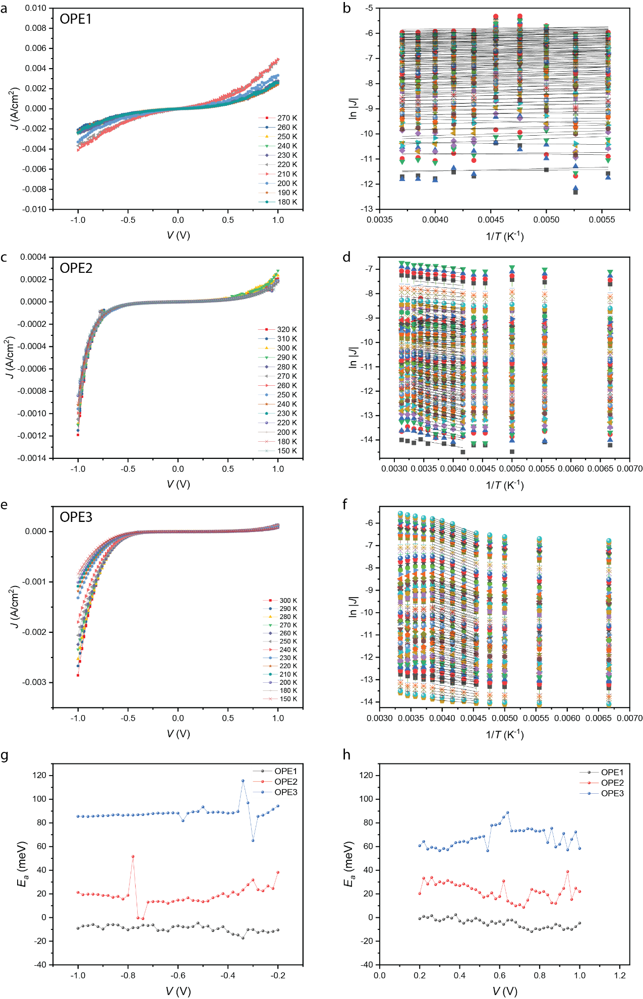

Figure 4. The temperature-dependent *J*-*V* data for SAMs of OPEn, n = 1 (a), 2 (c), 3 (e) and the corresponding Arrhenius plots (b), (d), (f). The activation energy *Ea* derived from the Arrhenius plots as a function of voltage at negative (g) and positive (h) bias. One junction for each type of SAM was shown in this figure. The complete data sets of three junctions can be found in the supplementary information.

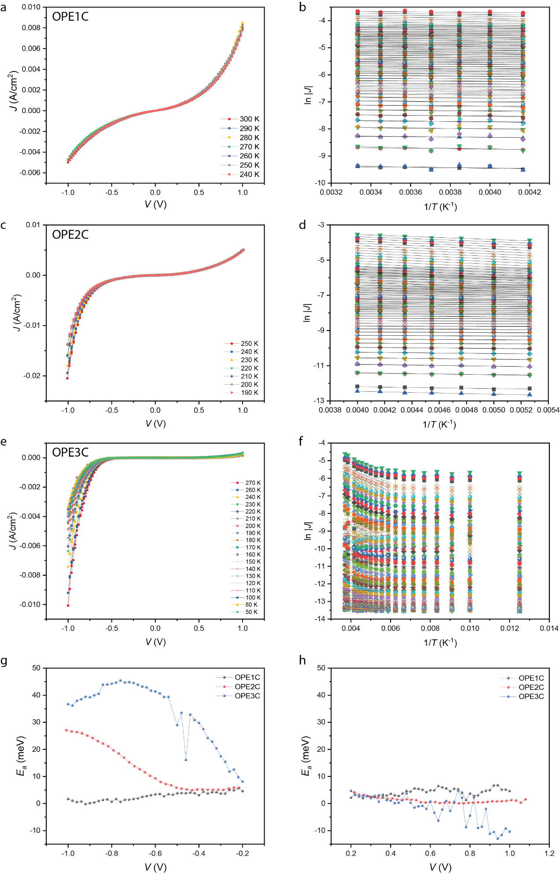

Figure 5. The temperature-dependent *J*-*V* data for SAMs of OPEnC, n = 1 (a), 2 (c), 3 (e) and the corresponding Arrhenius plots (b), (d), (f). The activation energy *Ea* derived from the Arrhenius plots as a function of voltage at negative (g) and positive (h) bias. One junction for each type of SAM was shown in this figure. The complete data sets of three junctions can be found in the supplementary information.

* Figure 4 (a) – (c) and (e) – (g) shows the *J*-*V* response of the junctions. The current densities of the junction are within one standard deviation of those from the same junctions using cone-shaped EGaIn tips as the top electrodes (Figure 3). The rectification ratios of the junctions remain the same as the result showed in Figure 3, indicating the rectification is caused by the molecules themselves. We can analyze the shape with NDC, will be done by Senthil.
* Figure 4 (d) and (h) shows the activation energy of the charge transport process as a function of bias voltage. The data from -0.2 V to +0.2 V was omitted because they are affected by capacitive current and does not provide insights for our discussion.
* For OPE1 and OPE1C, the charge transport process is virtually activationless (*Ea* ≈ 0), indicating coherent tunnelling. Another possibility is the leakage currents dominates for these junctions because the molecules are short and the SAMs are more prone to defects.
* For OPE2 and OPE3, a constant *Ea* was observed across the bias window, indicating hopping is the primary charge transport mechanism in these junctions. Longer chain length in OPE3 allows more time for the electrons to relax on the molecules, giving rise to higher activation energy.
* For OPE2C and OPE3C, a bell-shaped curve of *Ea* vs *V* is observed at negative voltage. This behaviour was predicted by Migliore et al. using a model based on Marcus theory applied in tunnelling junctions. It was later proven experimentally that the involvement of LUMO can push the charge transport into inverted Marcus regime. Here the position of the peak could represent the bias when both the HOMO and LUMO of the molecules are in the conduction window. The peak *Ea* values (30 - 40 meV) are lower than those for a typical hopping mechanism. We attribute this low *Ea* to the effect of nuclear tunnelling. The strong coupling between the ferrocene and the phenylene ethynylene units can make the charge transfer become non-adiabatic, lower the effective reorganization energy *λ*\*.

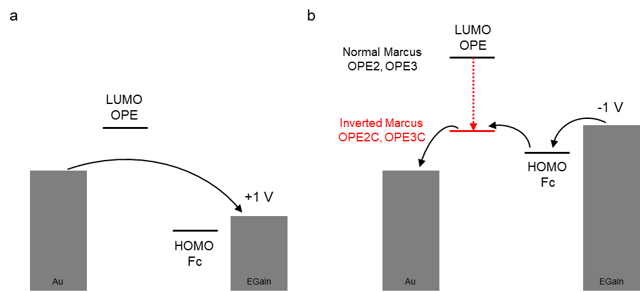

Figure 6. Energy level diagrams of junctions on (a) + 1V bias and (b) -1 V bias, where the black arrows indicate the electron transport and the red arrow indicates the shift LUMO level due to the intramolecular gating effect.

* From our previous study and the DFT calculation, we know that the HOMO of the molecules locates at the Fc groups while the LUMO locates at OPE. The HOMOs are about 0.7 – 0.8 eV apart from the Fermi level of Au. The LUMOs are more than 2 eV higher than the Fermi levels. Figure 6(a) shows the energy level alignment of the junctions at +1 V bias. Neither of HOMO or LUMO are in the conduction window and the electron transport by coherent tunnelling.
* Figure 5(b) shows that when -1 V bias is applied to the junction, the HOMO enters the conduction window. The Fc group can be charged due to its tendency to lose one electron to form ferrocenium (Fc+). This charged Fc+ can reduce the energy level of the LUMOs on the OPE part of the molecule, making the LUMO inside of the conduction window as well. In OPE2C and OPE3C, the weak coupling between OPE and the Au electrodes allows the electrons to localize on the LUMO. This intramolecular gating effect pushes the charge transport mechanism to the inverted Marcus regime and results in the bell-shaped curve of *E*a in Figure 5(g).
* In OPE2 and OPE3, the LUMO on OPE can delocalize through the sulfur atom and to the metal density of states. This strong coupling makes the electrons quickly dissipate to the metal. There is not enough time for the electrons to stay on the LUMO. As a result, the “gating” effect is not observed. The HOMO, however, is still weakly coupled to both electrodes, making hopping the dominating transport mechanism. The hopping in these two SAMs operates in the normal Marcus regime.

**Conclusions**

* We have again proven that inverted Marcus charge transfer can be realized via intramolecular gating. In addition, we have shown that this phenomenon can only occur if the molecules are weakly coupled to the electrode. We have demonstrated that one CH2 group to disrupt the conjugation between the molecules and the electrode can change the charge transport mechanism from normal Marcus regime to the inverted Marcus regime. Inverted Marcus transfer can make the electron transport activationless and have potential in energy saving in electric circuits. The possibility to fine-tune this mechanism could have profound implications for researchers to further explore this type of systems.